1. Design and Configuration of Star Topologies using Packet Tracer Star Topology using Hub:

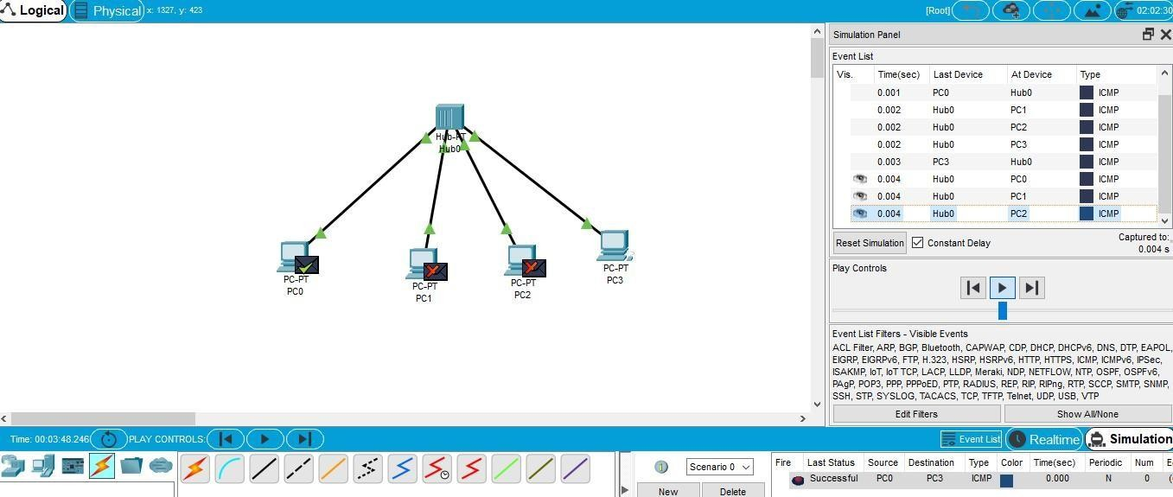

Star Topology using Switch:

